1. User management. Here we suppose there are at least two users, namely,
root and guest.

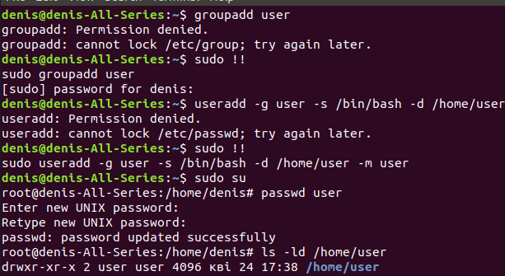

2. Content of /etc/passwd and /etc/group.

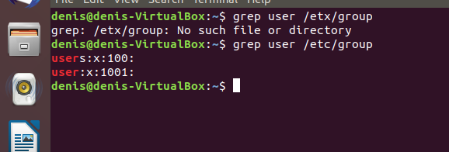

3. Dealing with chmod.

